Technical Documentation for Rails Scaffolding and Other Commands

**Joshua Cervantes**

Table of Contents

## Technical Documentation for Rails Scaffolding and Other Commands

## Rails Scaffolding

## Running a Server

## Configuring Routes

## Other Commands

## Removing from Database

**Rails Scaffolding**

To create a student model your portfolio_app run the rails generate scaffold with a name “Student” and its attributes set as strings or dates: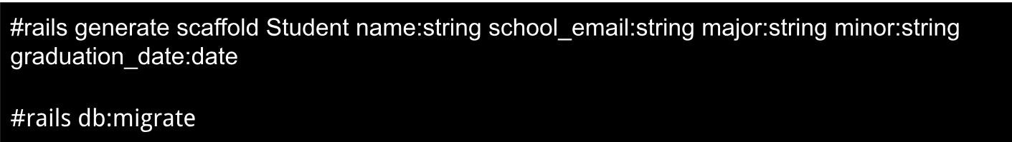

Db:migrate will migrate the student data into the database we have in rails.

**Running a Server**

To run a server with the new student page, run this command:



**Configuring Routes**

To see a student page and set the root to use the students resource, when your server is running, click on your **“config/routes.rb**” file within your portfolio_app and add this piece of code:

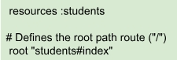

**Other commands**

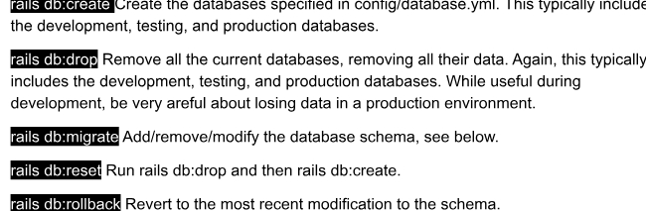

These are rails database commands that will allow you to navigate through a database.

**Removing from Database**

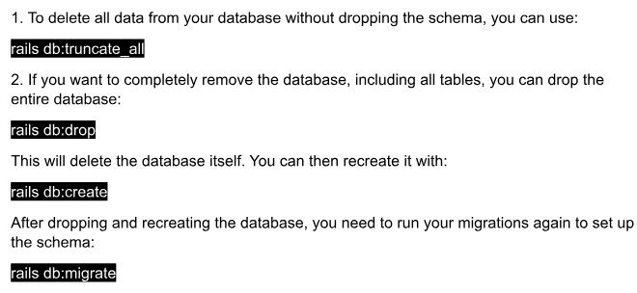

**Rollbacks and Removing a Scaffold**

